The Youngstown State University English Festival
and
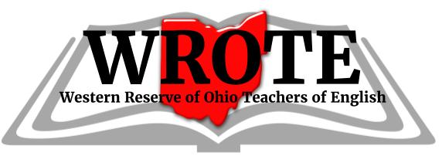
Cordially invite you to a dinner celebrating the
40th Anniversary of the English Festival
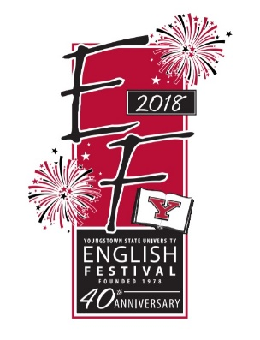
on the evening of Thursday, April 19, 2018

Celebrating Authors
Laurie Halse Anderson
Chris Crutcher
Kekla Magoon

DeBartolo Stadium Club, YSU Campus
Cost: $40/person, Appetizers, Dinner, and Desserts by Station Square
Cash Bar 6:30 pm, Dinner 7:00 pm
Baskets will be raffled
RSVP by April 12, 2018
Parking Available in the M-70 lot on Fifth Ave.
Dr. Gary Salvner will be providing reflections
on 40 years of the English Festival
_______________________________________________________________________________
Please detach and mail reservation and payment by April 12, 2018. Make checks payable to WROTE.
Names of all Guests:_____________________________________________________
Total Number of Guests___
Number of Vegetarian Meals _____
Would you like to join WROTE or renew your membership for $20? ____ Yes _____NO
Amount enclosed ______
Remit RSVP and payment to Dr. Jeff Buchanan, 880 Blueberry Hill Dr., Canfield, OH 44406

